 August 24, 2023

My beloved sisters and brothers,

Honour to the Divine Face in you and in me! With deep seated gratitude to God, I greet you all. I really thank God that I am able to reach you again. It has been a whole year, a period of very many commitments. Thank you for your understanding. I hope you and your families are doing well! We have continued praying for you, and will never stop.

The past year in Nigeria has been by far more problematic than before to the wellbeing and security of the citizens. The presidential election held early this year in that place has created chaos because of fraud. There now, life is very hard to sustain. The cost of things has gone up seven times higher than before. This consequently has given our service to the very poor and helpless people a lot of serious challenges. Many people are dying of hunger and lack of health care. Our school has also been affected adversely. Yet, by God’s Grace we are managing to survive. We still need good teachers, and it has been very tough to get them because we have the challenge of sufficient salary for teachers. The very bad economy of the country has caused a drop in the population of our school. The main problem is unbearable inflation. Also, the government’s total neglect of roads is causing the constant breakdown of our very old school buses. Good spare parts are very hard to find. The buses are really overdue for replacement.

In November last year, with your help, we bought a used bus, which is all we can afford. Unfortunately, the bus was very rotten but well painted. We had to replace the engine and its accessories in January. Other parts kept breaking and by July it could no longer be used. We have been compelled to buy another one through a more trusted agent. The toilet facility we built for our boys’ hostel got broken and cost quite a big sum of money to rebuild it. We are installing solar energy in our school to escape the choke of the cost of gasoline and diesel that has skyrocketed. Please join us in praying for Divine Intervention. Despite our partial scholarship for the children of those who were able to make some financial contribution, the population of our High School has gone very down. I wish we could give full scholarships to all the students. Many parents are financially unable to have their children come in as boarders. In the academic year that just ended, we had 265 children in the schools. Of these only 83 were in High School and only 21 were in boarding. We are currently offering opportunities of partial scholarship to all interested children who wish to come in as boarders. The children of the needy are always on full scholarship, including books, uniform and feeding, to help them break the bond and pass over the pit of poverty.

God the Son, Christ came into the world and used Our Lord Jesus, a human being, to close the very deep and wide pit of misery for helpless humanity enslaved by sin, the lack of God’s Grace. Our Lord Jesus Christ, The Source of God’s Grace, declared that His Act of Redemption from misery is for all peoples of all times and places. He lifted up humanity in Himself out of the pit of misery by His Resurrection. Then He took humanity in Himself up into the Glory of Heaven. He has called us as His followers to show that He is an effective Redeemer. Therefore, we have to remain God’s Instruments of Redemption for those in need. May the Holy Spirit please always make us aware of those whose needs He wants us to supply and enable us to accomplish God’s Design. Courage! The Lord is with you always. He will never abandon you who have made yourselves His Instruments of Loving Care for the needy. I hope you are already seeing evidence of His Presence in your lives!

Two of our Seminarians in East Africa are doing their best studying to be ordained Divine Face Stewards, who make your efforts bear fruit for the needy. I am truly very grateful for your faithfulness in your prayers and support. Please continue! We have two new candidates now. God is always at Work!

Please continue to help the Divine Face Community and Organization serving those who are helpless in the pit of misery. We are trying to manifest the Truth of God’s Promise to the needy: “In paths that they have not known I will guide them. I will turn the darkness before them into light, the rough places into level ground. This is what I will do for them, and I will not forsake them.”(Is 42:16)

Our Lord and God, Jesus Christ, will always be with you and your loved ones while on earth and at the end raise you up with Him to the Glory of Heaven. PRAISED BE OUR LORD JESUS CHRIST, THE DIVINE FACE! May He always shine His Grace on us!

Yours sincerely in The Divine Face,

Fr. Gerard Mary. A. Anyanwu

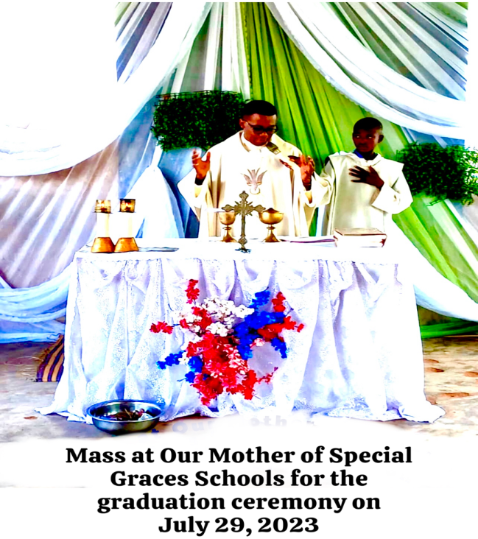

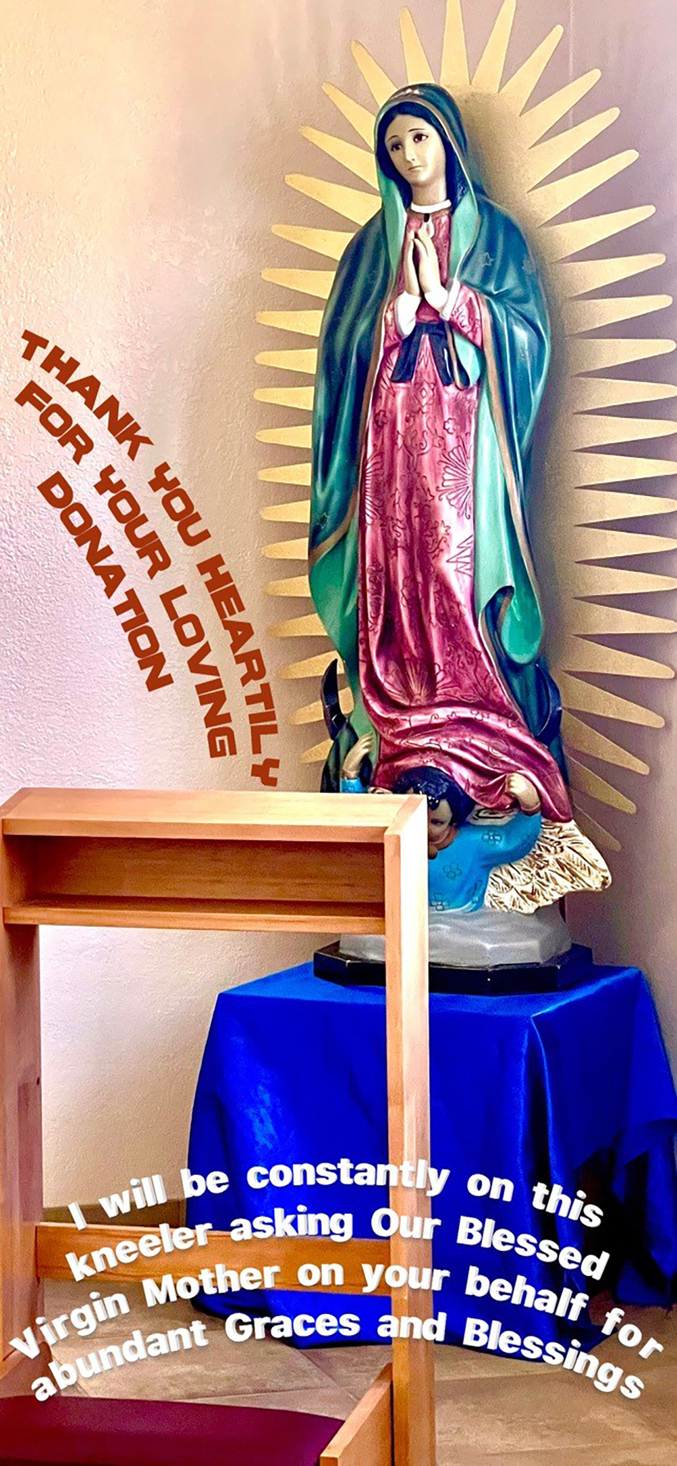

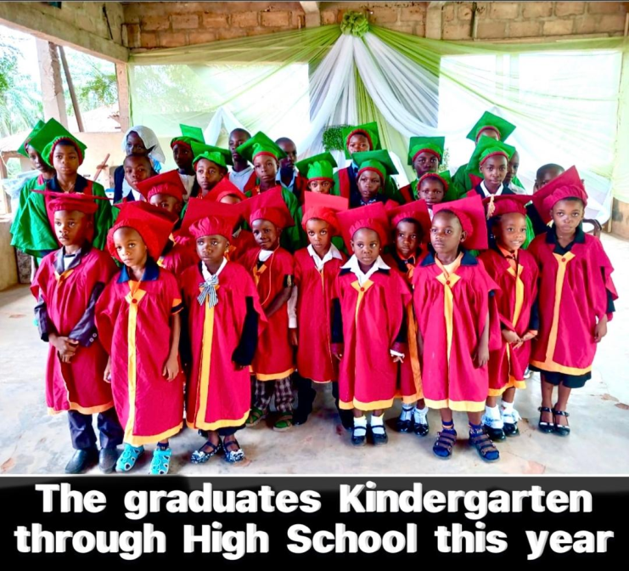

**Donation**

**Mass Request**  


**Divine Face Organization  
P.O. Box 171343  
Arlington, TX 76003-1343**

**divineface.wixsite.com/divineface**

Divine Face Organization is registered as a  
501(c)(3) non-profit organization