

**DIVINE FACE NEWSLETTER**

**HONOR TO THE DIVINE FACE, IN YOU AND ME!**

***JUNE 30, 2014***

**Beloved in the Divine Face,**

Peace to you from the Lord our God who is ***enthusiastic*** for our growth and fulfilment! He revealed this enthusiasm when He deliberately chose to come out of His hidden nature to show us His unconditional **Divine Love** with a **human face, Our Lord Jesus Christ.** We have all been called into Christ to be, **each of us, *the visible experience of the hidden Love of God – the Divine Face – in our time.*** THANK YOU FOR BEING THERE FOR HIM!

Today is the **Feast of our Mother of Special Graces**. I salute every one of you in Her name. You have willingly responded with your donations to make the uplifting hand of the Divine Face real in the life of the needy. In this way you are making known to the lowly the greatness of the Almighty God as the Blessed Virgin Mother did. She willingly ***made Herself available*** at God’s call to give Him what He needed to make His love to be experienced by helpless humanity. May He continue to bless you for your witness that He is still at work for the good of His children!

God the Word has translated in human form God’s loving will to make human beings His children. God the Holy Spirit has given us the ability to understand this message, to make God’s Will real in us and to pass on the message. This is what we have been trying to do with your **very commendable** help these past **twenty years**. ***YES, THIS IS THE TWENTIETH ANNIVERSARY OF THE DIVINE FACE ORGANIZATION IN THE USA! HAPPY ANNIVERSARY OF UNION IN CHARITY TO YOU ALL!!***

This year also is the 40th anniversary of my ordination as a priest. Please join my family, relatives, friends, the Stewards of the Divine Face and the Divine Face Organization and me in thanking the Almighty and merciful God who called and chose me for this privilege which **no one ever deserves**. He has truly been patient with me all these years. However, I strongly believe that Our Mother of Special Graces has not stopped even for one moment to make Her usual unrefusable intercession on my behalf. It was because of Her overwhelming **Motherly protection** that I modified my name at my **Silver Jubilee** in 1999 to **Gerard Mary**. She has been magnificent and I know She is not tired of me yet, **and will never be** for the sake of Her Divine Son, our Lord Jesus Christ who graciously has chosen to share His priesthood and life with **a nonentity like me**.

***YOU ARE INVITED TO THE CELEBRATION OF THESE TWO ANNIVERSARIES ON AUGUST 2, 2014 HERE IN ARLINGTON.*** I am sure you will be glad you did!

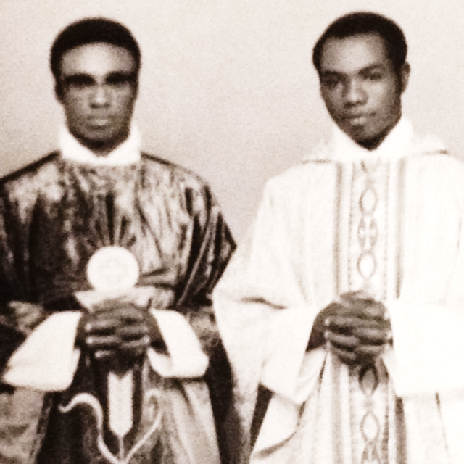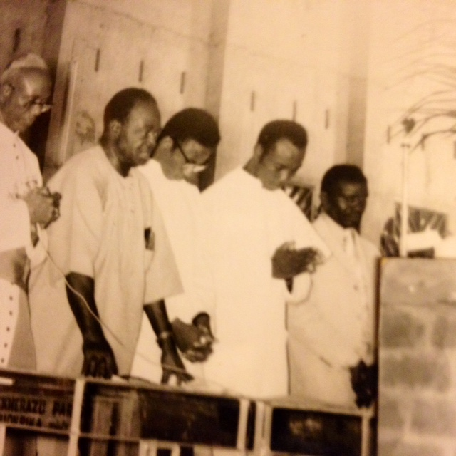

My colleague Fr. Matthew Iwuji and I right after our ordination.

The ordaining bishop extreme left. The two-just ordained in the middle, 1st Sunday after Easter 21/04/74

It still seems to me as if it was just last year, except that I don’t know where the hair on my head has gone, nor do I care!

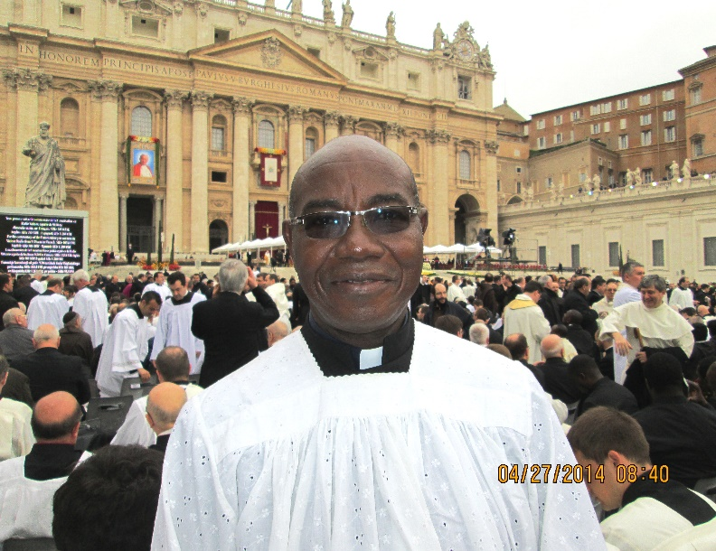 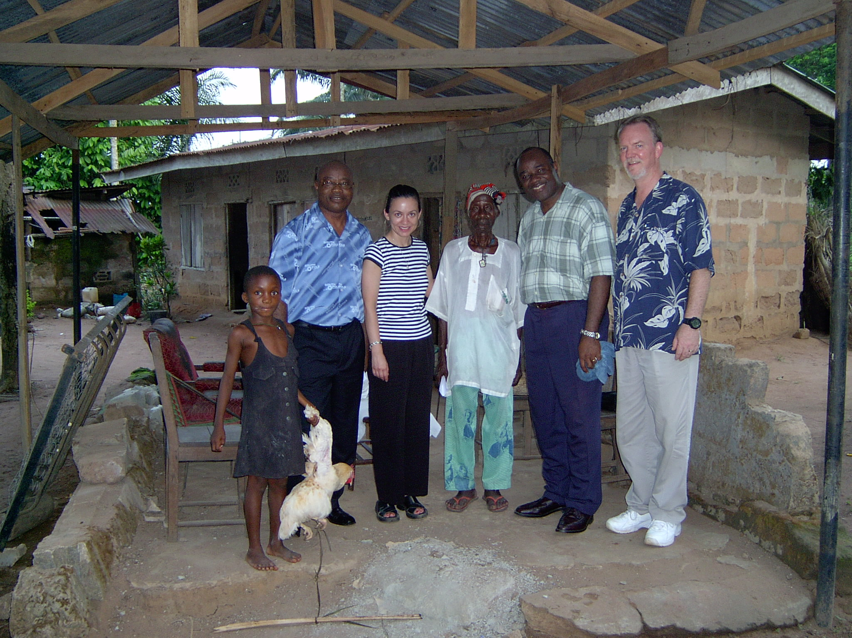

This is what I look like now, forty years later. At St Peter’s Rome for the canonization of the two Popes.

In the meantime God’s active love has united the US and Nigeria in giving a **Face of Compassion** to the poor and needy- the **DFO**

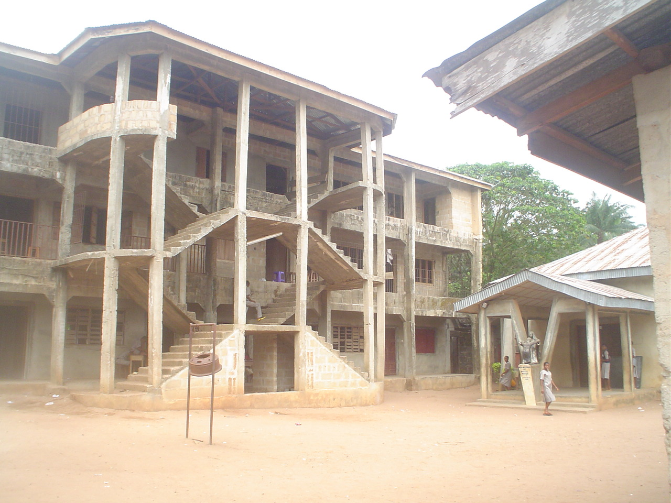 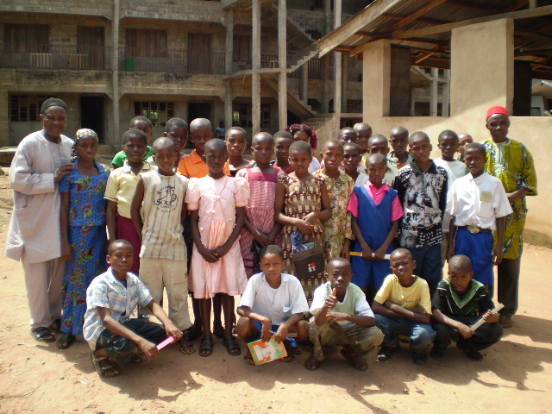

Here are some of those children at the school for admission.

The **Divine Face Org.** has built a K-H school for the poor since 1992, among other things.

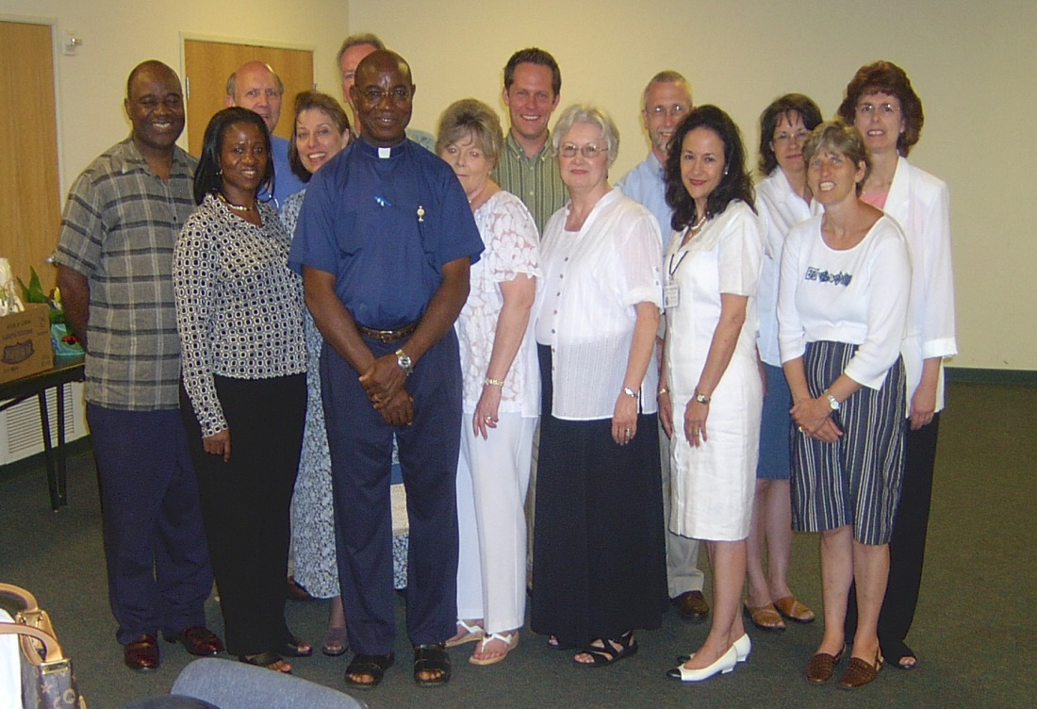 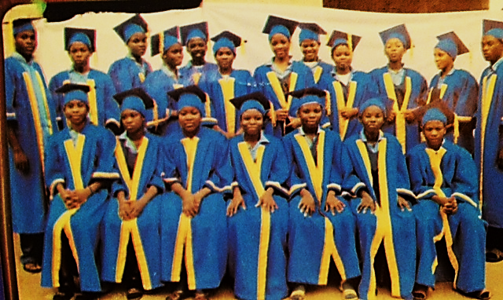

Some of the 9 sets of graduates from our High school.

Some members of the **DFO**, who have been God’s effective stewards of His Kingdom of **Love.**

This academic year which ends on July 28, we have 250 children in the school and 28 members of staff taking care of them. Of these, five are our ex-students who have volunteered to help out. One of them has finished his first degree and before going on to do his Masters’ program chose to come and witness to our students about the importance of the training we try to give children in our school. Another one is about graduating from college. But since he left our school, he has been regular in coming almost every week to teach some subjects and also help in the formation of the students, telling them what a difference he saw in the university he is in between being disciplined and undisciplined. Many others have also graduated from college and are working.

Not less than five of our ex-students are in the Seminaries studying for the priesthood. One is a novice in a religious Congregation for women. Practically most of my life as a priest I have been involved particularly in the formation of young people, both for the priesthood, religious life and for a purposeful and God-centred life of positive contribution for the good of society. I recently remembered that when I was in the major Seminary, I had requested the Lord to make a priest for the youth. I am most grateful to Him that He has maintained that **hunger** in me by giving me some **taste** of its fulfilment. Above all, I revere Him for His patience with my great limitations.

I certainly would not have been able to get to where I am today in my journey to answer His call without you. Everyone of you has been a **special grace** from the Source of all the **peculiar graces** that He has for every task He allots to individuals. He is the Master of the Vineyard and knows how to equip His labourers for the expected harvest. I like to reciprocate by praying that you approach your own call with **courage**, one of the gifts of the Holy Spirit, which someone said is not simply one of the virtues, but the ***form*** of every virtue at the testing point. Trust in God makes one climb any wall God requires.

Let me conclude with this favourite prayer of mine: ***Father, Lord of the Vineyard and the Harvest, You allot us our tasks and determine the just rewards of our labours. May the Holy Spirit help us to know our task and to work at it with zeal, bearing the burden of the day and accept Your Will in all things with serenity; through Christ our Lord. Amen.***

Rev. Fr. Gerard Mary A. Anyanwu